Software Testing LO3
Samad Ali
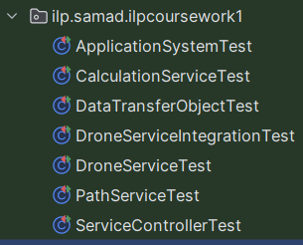
The testing phase of this project covered the full cycle of the medical drone delivery REST service. This included areas such as geometric calculations, drone selection logic, A* pathfinding, system performance and robustness. This document outlines the techniques I applied, evaluates the adequacy of my tests, and finally evaluates the system against my original R1, R2 and R3 requirements. Detailed test result tables (unit, integration, system and Postman) are included in the ‘LO3 Test Results’ document.
3.1 Range of techniques
Multiple layers of testing were used, from unit, to integration, to system testing. This ensures the validity of individual components, as well as stability of the system.
Unit Testing (White Box)
Figure 1: Test Classes
The unit tests made use of JUnit 5 and Mockito, allowing isolation of testing to logic specific to the method being tested, rather than relying on other functions. This phase focused on ‘white box’ testing, examining internal logic.
Methods tested
- Geometric Logic (CalculationService)
  - Tested calculateDistance, calculateClose, calculateNextPosition, and calculateIsInRegion.
  - Focusing on edge cases, such as boundaries of what is acceptable (e.g. point in a corner), or points in the same location. Also aimed for comprehensive tests, such as testing all 16 possible compass directions for the correct result.
  - Exceptional cases verified that the service will correctly throw exceptions for invalid movement angles (non 22.5 increments, negative angles, or 360+).
- Drone Filtering (DroneService)
  - Tested isDroneAvailableAtTime, getDronesByQuery, getServicePointForDrone, getServicePointById.
  - Focus was on trying to mock the external service as accurately as possible to ensure realistic test scenarios. Incorporated boundary and negative type tests.
- Pathfinding Logic (PathService)
  - Tested doesLineIntersectPolygon, reconstructPath, heuristic.
  - Focus was mainly on the avoidance of corner cutting, as this was a key criteria repeated throughout previous LO documents. The test ensures that even if a path only goes through the corner of a restricted area, it is still flagged as intersecting the area.
Integration Testing
This verifies the interactions between different services and external dependencies.
- Validated the interaction between FlightService, DroneService, and PathService. This ensured that drone selection logic (R2) is correctly sent parameters to the pathfinding algorithm (R1). This ensures the path found meets the constraints of the drone.
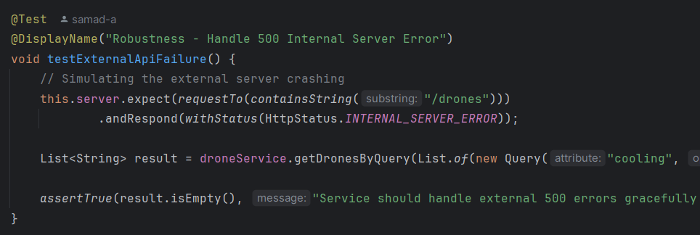
- Using MockRestServiceServer to simulate the external ILP service, I performed fault-injection testing. This allowed for robustness testing, where I simulated a 500 Internal Server Error. I used this to check that rather than crashing, the service logs the error and returns an empty flight plan, so the system remains available.
Figure 2: Test simulating a 500 Internal Server Error from external ILP service
System Testing (Black Box)
System testing was used to validate the full application end-to-end and ensure that it meets user requirements.
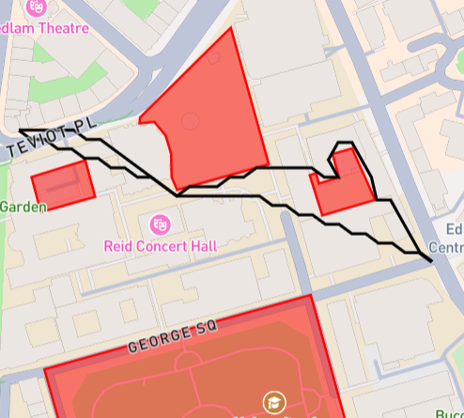
- Tests executed on the final Docker container to ensure the 30 second runtime limit is validated on the platform we are likely to deploy the final version on. A batch stress test with 20 MedDispatchRec orders was used, using System.currentTimeMillis() it showed a processing time of 14.2 seconds.
Figure 3: Restricted areas and path visualised on geojson.io
- Used Spring Boot’s /actuator/health endpoint to verify the system’s status.
- GeoJSON responses were validated manually for complex path through an online visualiser, to ensure that requirements are met.

Regression testing
- A comprehensive suite of tests in a Postman Collection was used to automate endpoint validation, ensuring that after any changes to the code, endpoint HTTP responses remained correct. This included checking valid JSON returns a 200 OK, malformed JSON returns a 400 Bad Request, and missing drone IDs return a 404 Not Found.
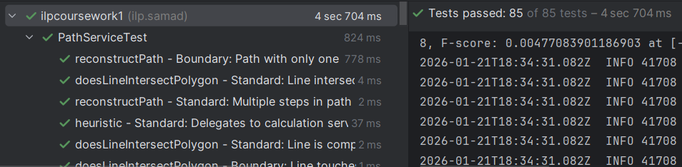
3.2 Evaluation criteria for the adequacy of testing
Figure 4: Running all 85 tests on IntelliJ, all pass
The following criteria were used to evaluate adequacy of testing:
Code Coverage
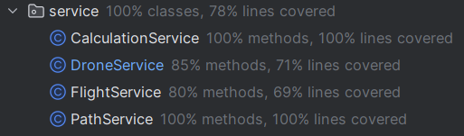
Using IntelliJ’s code coverage tool, I achieved 100% line coverage for the CalculationService and PathService geometric methods. This was essential as the logic of these services is the backbone of the drone delivery system. DroneService and FlightService also had high coverage of around ~70%.
Figure 5: IntelliJ Code Coverage, 100% for CalculationService and PathService
Boundary Value Analysis
In addition to code coverage, I used boundary testing when possible for methods such as calculateClose and isInRegion. This ensured that they worked correctly for edge cases, e.g. if co-ordinates are at the 0.00015 closeness boundary, it should return false.
Traceability to Original Requirements
Every test case was mapped back to the requirements established in LO2 where possible.
- R1 (Navigation): Verified with doesLineIntersectPolygon tests (preventing corner-cutting) and visual GeoJSON validation. Also tested all 16-point compass direction tests, ensuring movement of the drone is accurate for all possible angles.
- R2 (Drone Selection): Verified with availability and capability matching tests, mocking a response from the external ILP service with Mockito.
- R3 (Performance): Verified with System.currentTimeMillis() during 20 order batch test, ensuring it is calculated within the 30 second time constraint.
3.3 Results of testing
Extensive details on testing results, including individual test outcomes, parameters and specific coordinate sets, are available in the accompanying 'LO3 Test Results' document. Please refer to that document for this section, as it was too long to include here.
3.4 Evaluation of the results
The testing process was effective, especially as it allowed me to identify a critical failure point in the DroneService before final deployment.
Integration testing revealed that a connection timeout to the external ILP service caused a system crash. By identifying this, I implemented defensive try-catch blocks which interact with the global exception handler, ensuring system availability even during external service outages. This demonstrates the link between testing and software being robust.
The quality of code instrumentation also benefited tests, as using System.currentTimeMillis() allowed us to validate the performance of the system (R3).
Strengths
The high coverage in unit testing (100% for some classes) provides strong evidence that the drone’s movement is correct, especially the mathematical logic behind it. The use of Pythagorean triples in Euclidean distance tests was a deliberate choice to ensure mathematical precision and eliminate floating-point rounding errors.
Running the full system test suite within a Docker container ensured that the performance metrics (R3) and runtime limits were validated in an environment identical to the production deployment.
The use of an automated Postman Collection verified that the service adheres to the REST specification across all status codes. This included 200 OK for valid JSON, 400 Bad Request for malformed JSON and 404 Not Found for missing drone IDs.
System testing confirmed that a batch of 20 orders is processed in 14.2 seconds, which is only 47% of the 30 second maximum allowed by requirement R3, allowing for a large safety buffer.
Limitations
While the A* search implementation works well for standard polygons, I didn’t have time to test it with more complex shapes or overlapping areas, going forward I would include more tests for more difficult scenarios and ensure it still works correctly.
Stress testing of delivery path calculation was only done for batches of 20 orders, in a real world scenario there may be large influxes of over 100 orders at once, so larger batches could be tested with. This also requires more sample data to use for testing
Lack of network latency simulation, integration tests used local mocks rather than simulating the network jitter or latency which the external ILP service may have. In a real-world deployment, slow responses could still cause the service to exceed the 30 second R3 limit.
Conclusion
The testing done confirms that the service satisfies all the core requirements previously laid out. It combines mathematical verification through unit tests with full system validation, allowing for a high degree of confidence in the end service.

